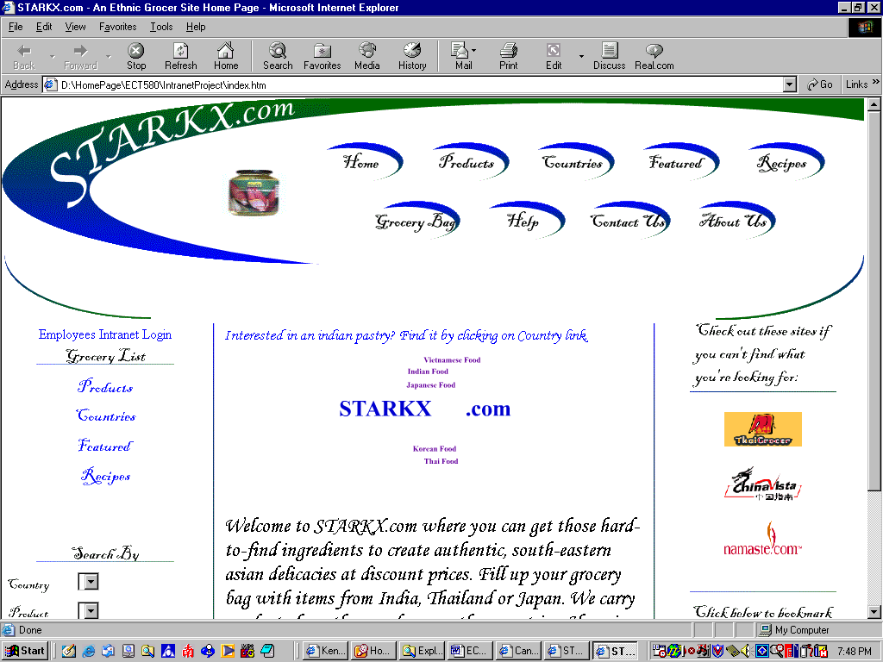

After click on the Employees Intranet Login, which is located on left hand side. It will go to the following page:
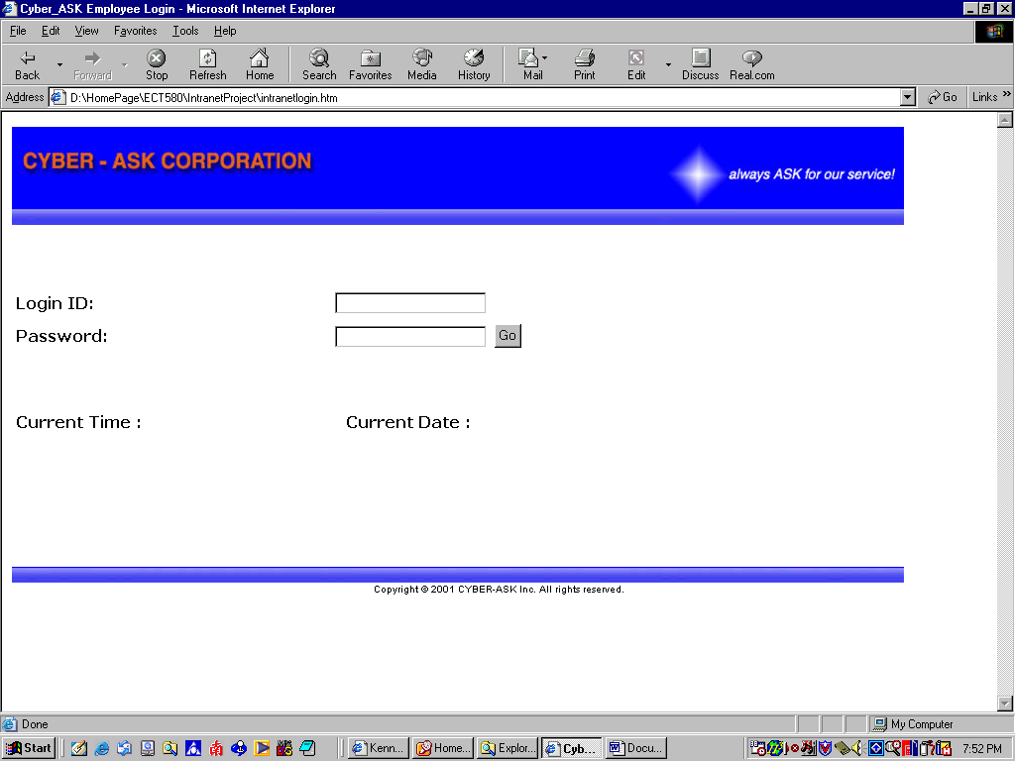
The screen-shot are the index page and intranetlogin page of the Starkx.com. Due to the student account - ASP Server is expired after June 2003. The new server does not support for the ASP files. If you are interested in my project, I will demonstrate on my laptop. Sorry for the inconvenient.

