Team: “Cyber-ASK”
ECT 580: Intranet Project - Design Phase
October 4, 2001

- Information with a single document (screen)

    - Information Organization:

  - STARKX.com will integrate the Intranet with its current web site.
  - The page layout and design of the Intranet will be similar to the existing layout to maintain a consistent 'look and feel'
  - Meta Tags: A short description of the web page will be incorporated to make query retrieval faster and efficient.

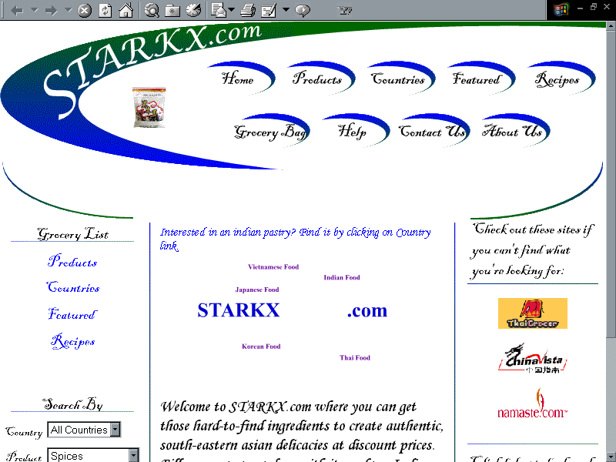
Home Page: Layout

- Program design

Structured design:

Home Page

Employee Login

Employee discount
Processing
Survey
Tool
Processing
Employee
Survey Tool
Employee Benefit plans
Training
Materials
Employee
Discounts

Corporate News/Alerts
Project Tracking Application
Products
Cart
View Order
Confirm Order
Plain HTML information
Page
Plain HTML information
Page
Plain HTML information
Page
Plain HTML information
Page
Survey 1
Survey 2
Survey 3
Countries
Featured
Search
Recipes

Note: The entry point for the Intranet will be an "EMPLOYEE LOGIN" button which will be incorporated in the home page of STARKX.com

- Navigation design

3.1 The entry point:
The entry point for the Intranet will be an "EMPLOYEE LOGIN" button in the home page of STARKX.com.
The EMPLOYEE Login Screen (which will be first screen for the Intranet) will include the following:
  - Company Logo
  - An overview of what is available on the site
  - Top navigation bar (include home, on-line training, on-line survey, project status, employee discount, help, contact us)
  - Left navigation bar (include on-line training, on-line survey, project status, employee discount)
  - Footer (include copyright & sitemap)

3.2 Navigational elements:
A navbar will be including all the main sections of the site; furthermore, it will be the same on every page of the site.

3.3 Navigation design:
WEB Based: Our navigational design will allow our employees to reach all sections of our site from any page due to the implementation of a well-designed navigation system. The top navigation will always look the same on all pages.

3.3 Directory Structure:

Employee
-- Employee Info -- Photo (Images)
-- Record (PDF)

-- Discount -- Product
-- Country
-- Features
-- Search
-- Recipe
-- Images
-- Order Form -- Code (ASP)

-- Training -- Sales
-- IT
-- Finance

-- Survey -- Survey 1
-- Survey 2
-- Survey 3

-- Benefit -- Policy

-- News -- Press release
-- Organizational Announcements
-- Project Track

- Page layout and graphic design

5.1 Structuring element:

5.1.1 Headings:
  - H1 heading will be used to draw attention that the page is important
  - Text organization will be kept to maximum of three levels.

5.1.2. Captions and Lists:
- Caption will be used to uniquely identify the illustration/ tables.
- Numbered or ordered lists will be used wherever necessary.

5.2 The length and width of the web page:
STARKX.com will follow the following guidelines for page layout.

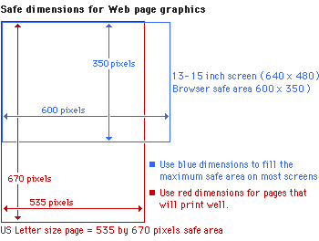

5.3 Consistency of design: layout and color stability:
General guideline applicable to all pages: each page will have the same paragraph styles, for example the default font, size and color will be specified in the style sheet. These will be used consistently throughout the site.

5.4 Graphic Design
Graphics will be kept to minimum on the Intranet to ensure faster retrieval of information and to prevent network clogging. The graphic format used will be JPEG and GIF.

- Security design

Web server security
Username/password authentication will be used as a mechanism for restricting access to web sites. To begin with the data will be sent by POST method to ensure data security. At a later stage CYBER-ASK will use SSL to guarantee the authenticity of the server and integrity of the data delivered to web site users, and to protect visitors' responses to interactive elements on the site.

