Question 1: Based on L2 and Df measures, which model (4 cluster or 5 cluster) is better?
Answer 1:
Cluster | L² or (LL) | BIC | Df | p-value
4-Cluster | 8.4828376 | -62.529519 | 8 | 0.39
5-Cluster | 7.5385980 | -10.214491 | 2 | 0.023

The lower the value of LL, the better the fit of the model to the data. However, as a rule of thumb, a model provides a good fit when the LL is not substantially larger than the degrees of freedom (Df) associated with model. From the above table, it seems 5-cluster has the lower value of LL, which is 7.538. However, the LL is substantially larger than the Df in 5-cluster. It has 5.538 (7.538 – 2) substantially different. The LL is not substantially larger than the Df in 4-cluster, it has only 0.483 (8.483 – 8) different. Also, the p-value of 4-cluster is 0.39, which is the closest value just greater than 0.05, which satisfies the statistical criterion. Therefore the 4-cluster is better than the 5-cluster.

Question 2: Based on the PROFILE information compare cluster sizes for 4 cluster and 5 cluster models.
Answer:
Below is the Profile of 4-cluster
 | Cluster1 | Cluster2 | Cluster3 | Cluster4
Cluster Size | 0.6061 | 0.2131 | 0.1198 | 0.061
BACK
No | 0.9353 | 0.3179 | 0.6065 | 0.0946
Yes | 0.0647 | 0.6821 | 0.3935 | 0.9054
NECK
No | 0.9573 | 0.4484 | 0.7755 | 0.1645
Yes | 0.0427 | 0.5516 | 0.2245 | 0.8355
JOINT
No | 0.9338 | 0.5993 | 0.1065 | 0.0485
Yes | 0.0662 | 0.4007 | 0.8935 | 0.9515
SWELL
No | 0.9802 | 0.9557 | 0.5489 | 0.4407
Yes | 0.0198 | 0.0443 | 0.4511 | 0.5593
STIFF
No | 0.9864 | 0.8843 | 0.592 | 0.0966
Yes | 0.0136 | 0.1157 | 0.408 | 0.9034

Below is the Profile of 5-cluster
 | Cluster1 | Cluster2 | Cluster3 | Cluster4 | Cluster5
Cluster Size | 0.6040 | 0.2092 | 0.0840 | 0.0636 | 0.0392

BACK
No | 0.9326 | 0.3210 | 0.5022 | 0.1658 | 0.7622
Yes | 0.0674 | 0.6790 | 0.4978 | 0.8342 | 0.2378

NECK
No | 0.9593 | 0.4350 | 0.9429 | 0.0317 | 0.6896
Yes | 0.0407 | 0.5650 | 0.0571 | 0.9683 | 0.3104

JOINT
No | 0.9342 | 0.5943 | 0.0876 | 0.0587 | 0.2474
Yes | 0.0658 | 0.4057 | 0.9124 | 0.9413 | 0.7526

SWELL
No | 0.9826 | 0.9627 | 0.5564 | 0.4326 | 0.5414
Yes | 0.0174 | 0.0373 | 0.4436 | 0.5674 | 0.4586

STIFF
No | 0.9859 | 0.8833 | 0.4346 | 0.1348 | 0.9645
Yes | 0.0141 | 0.1167 | 0.5654 | 0.8652 | 0.0355

For the 4-cluster model, Cluster 1 contains about 61%, Cluster 2 contains 21%, Cluster 3 contains 12%, Cluster 4 contains the remaining 6% of respondents.

For the 5-cluster model, Cluster 1 contains about 61%, Cluster 2 contains 21%, Cluster 3 contains 8%, Cluster 4 contains 6%, Cluster 5 contains the remaining 4% of respondents.

Cluster 1 and Cluster 2 obtained from the 5-cluster model are very similar to the corresponding clusters obtained from the 4-cluster model. They have 61% contained by Cluster 1 and 21% contained by Cluster 2.

For the 4-cluster model, Cluster 1 respondents report very few symptoms – about 7% report back pain, 4% report neck pain, 7% report joint pain, 2% report swelling, and 1% report stiffness.

For the 5-cluster model, Cluster 1 respondents report very few symptoms – about 7% report back pain, 4% report neck pain, 7% report joint pain, 2% report swelling, and 1% report stiffness.

Both cluster models have almost the same percentage of report in those symptoms. Also, over half report have back pain and neck pain on the cluster 2 of both cluster models.

On the 4-cluster model, almost 90% of Cluster 3 respondents report joint pain. On the 5-cluster model, 91% of Cluster 3 respondents report joint pain. Furthermore, almost 50% of Cluster 3 respondents’ reports have all symptoms.

Both cluster models have a high incidence of all 5 symptoms on Cluster 4 respondents report.

On cluster 5 of 5-cluster model, every symptom has decreased the percentage report compared to the cluster 4 of 5-cluster model. Joint pain still has the highest percentage report, which is 75%.

Question 3: Retrieve PRF-PLOT graphs for 4-cluster and 5-cluster models. Include both models in the deliverable and analyze both graphs.
Answer 3:

Below is the PRF-PLOT graph for 4-cluster model
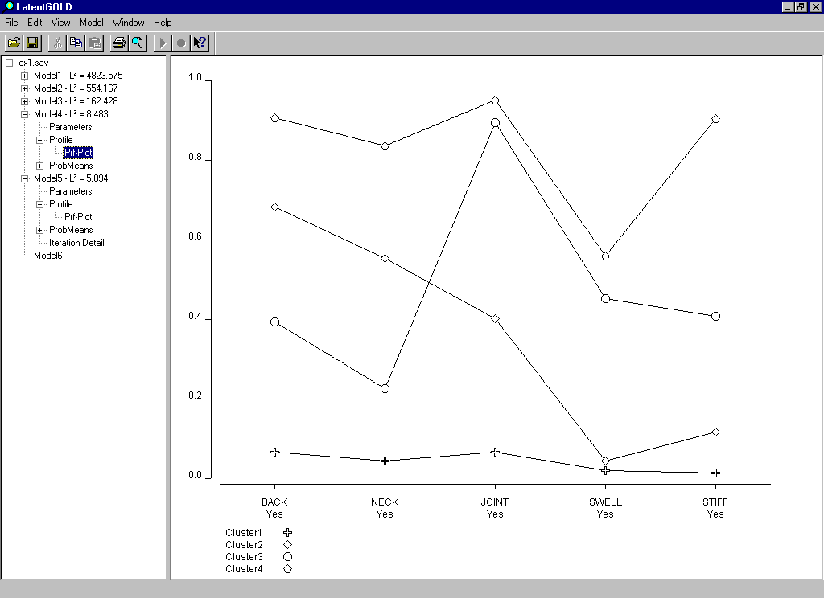

From the above graph, the cluster 1 is the cross symbol, which has low percentage, less than 10% in every symptom. Cluster 2 is the diamond symbol, which has high percentage report in back pain and over half report have back pain and neck pain. Cluster 3 is the circle symbol, which has high percentage, almost 90%, report in joint pain. Cluster 4 is the pentagon symbol, which has over 80% report in back pain, neck pain, joint pain, and stiff pain. Swell pain has the lowest percentage report compare to other symptoms.

Below is the PRF-PLOT graph for 5-cluster model
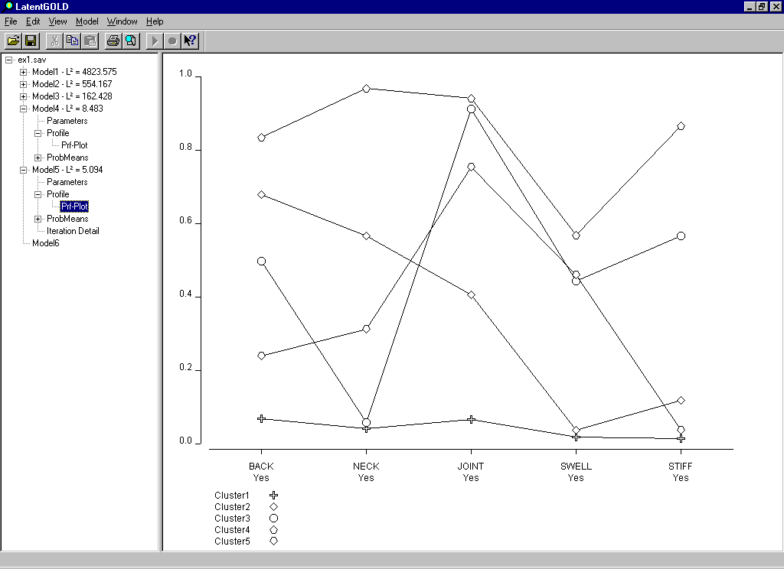

From the above graph, the cluster 1 is the cross symbol, which has low percentage, less than 10% in every symptom. Cluster 2 is the diamond symbol, which has high percentage report in back pain and over half report have back pain and neck pain. Cluster 3 is the circle symbol, which has high percentage, around 91%, report in joint pain. Almost 50% of Cluster 3 respondents’ reports have all symptoms, except neck pain. Cluster 4 is the upper pentagon symbol, which has over 80% report in back pain, neck pain, joint pain, and stiff pain. Swell pain has the lowest percentage report compare to other symptoms. Cluster 5 is the lower pentagon symbol, which has low percentage report in back pain and neck pain. Joint pain still has the highest percentage report, which is 75%.

Question 4: Retrieve Tri Plots for both models and include in your discussion. Find what are the conditional probabilities of Back pain (Y) and Neck pain (Y) belonging to clusters 1 and 2. Find the conditional probabilities of both health problems belonging to other clusters from the relevant table.

Answer 4: Below three tables are Tri Plots for 4-cluster model and 5-cluster model.

Below is the Tri Plots graph for 4-cluster model
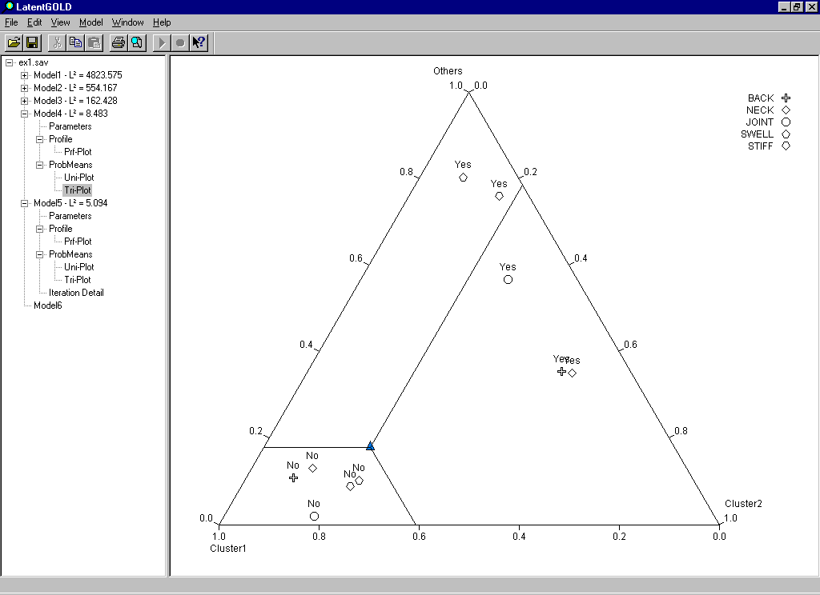

Below is the Tri Plots for 4-cluster model, which highlight the neck pain
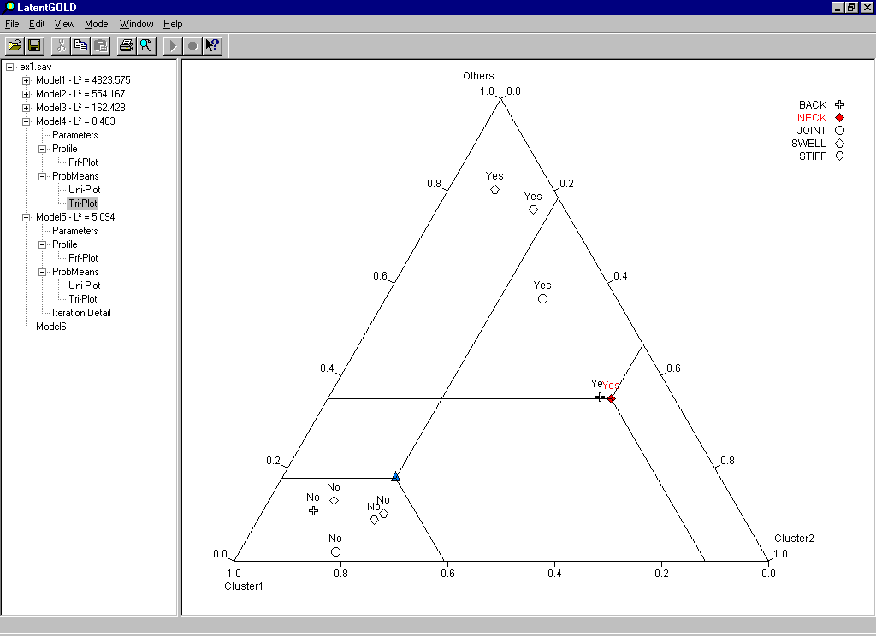
From the above graph, a triangle symbol at the centric of the triangle is used to represented the mean observation, and is plotted at the point corresponding to the overall cluster probabilities obtained from the first row of numbers in the ProbMeans table. The symbols indicating absence of symptoms are located next to each other (close to the Cluster 1 vertex). This suggests that persons without any symptoms are most likely to be in Cluster 1. The symptoms of back pain and neck pain have low percentage in cluster 1. On the cluster 2, the back pain and neck pain report are plotted very close to each other indicating that persons reporting either have similar cluster membership probabilities. It has high percentage report in both back pain and neck pain, which has over 50 percent.

Cluster 3 and 4 are combined in the Tri-Plot for the 4-cluster model and are represented by the top vertex, labeled ‘Others’. The symptom of swell pain has 80%, highest percentage compare to other symptoms in the others cluster.

Below is the Tri Plots for 5-cluster model, which highlight the neck pain
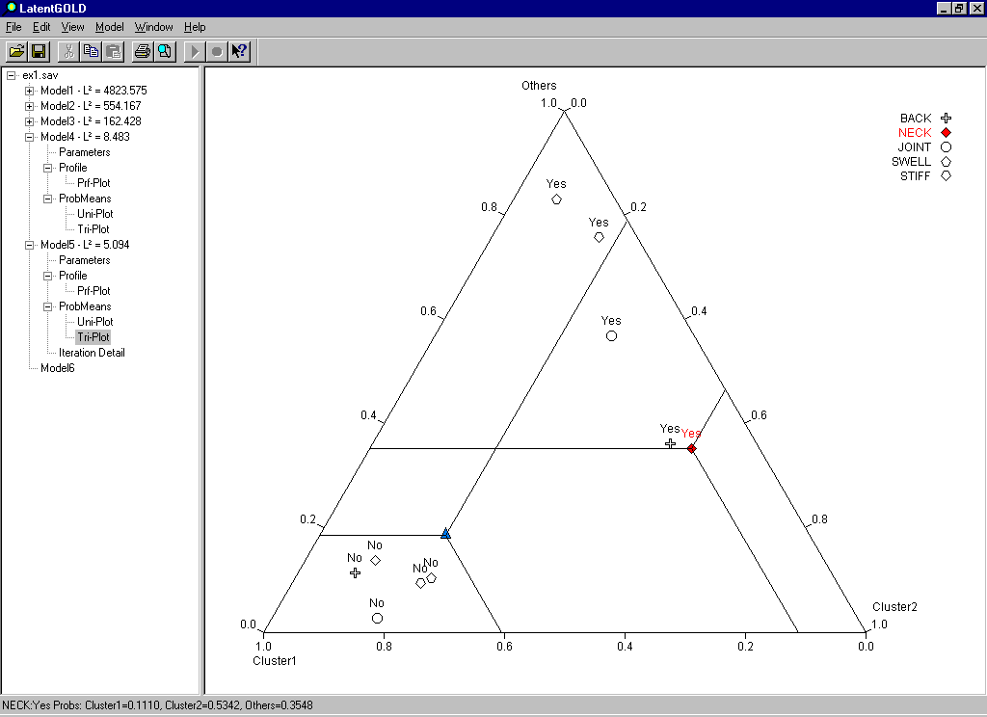

From the above graph, a triangle symbol at the centric of the triangle is used to represented the mean observation, and is plotted at the point corresponding to the overall cluster probabilities obtained from the first row of numbers in the ProbMeans table. The symbols indicating absence of symptoms are located next to each other (close to the Cluster 1 vertex). This suggests that persons without any symptoms are most likely to be in Cluster 1. The symptoms of back pain and neck pain have low percentage in cluster 1. On the cluster 2, the back pain and neck pain report are plotted very close to each other indicating that persons reporting either have similar cluster membership probabilities. However, on the 5-cluster model, both symptoms are not close together comparing to 4-cluster model. It has high percentage report in both back pain and neck pain, which has around 50 percent.

Cluster 3, 4, and 5 are combined in the Tri-Plot for the 5-cluster model and are represented by the top vertex, labeled ‘Others’. The symptom of swell pain has over 80%, highest percentage compare to other symptoms in the others cluster.

