Assignment 2

Question 1. Analyze stores in Americas. Find a day of week with the highest amount of sales for stores in this region.
Answer 1.
Region | Amount Sales | Day Name
Americas | 11,066,850.14304 | Sunday
Americas | 10,305,004.03708 | Thursday
Americas | 10,242,916.98515 | Friday
Americas | 10,019,038.47421 | Monday
Americas | 9,948,196.48724 | Saturday
Americas | 8,637,474.3886 | Tuesday
Americas | 8,536,354.00357 | Wednesday

Question 2. Find a day of week with the highest book unit sales.
Answer 2.
Day Name | Book Unit Sales
Sunday | 550,734.
Tuesday | 546,173.
Monday | 529,361.
Wednesday | 521,915.
Saturday | 488,327.
Friday | 479,817.
Thursday | 445,328.

Question 3. Generate a chart that tells which day of week has the highest book unit sales.
Answer 3.
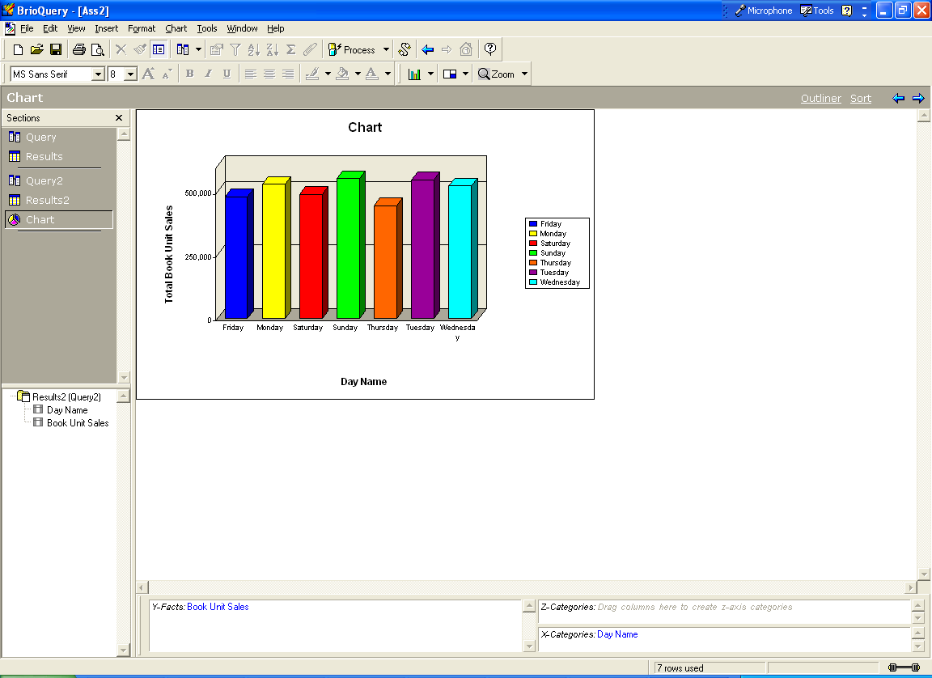

Question 4. Generate a report (using a pivot) that tells a day of the week with the highest book unit sales by different regions.
Answer 4.
 | Americas | Asia Pacific | Europe
 | Unit Sales | Unit Sales | Unit Sales
Friday | 219,291. | 91,768. | 168,758.
Monday | 233,508. | 150,049. | 145,804.
Saturday | 224,213. | 151,357. | 112,757.
Sunday | 259,187. | 146,506. | 145,041.
Thursday | 232,729. | 101,995. | 110,604.
Tuesday | 207,232. | 162,869. | 176,072.
Wednesday | 187,296. | 148,137. | 186,482.

Question 5. Generate a report (using a pivot) that tells a day of the week with the highest book unit sales by different countries.
Answer 5. 5.
 | Argentina | Australia | Brazil | Canada | France | Germany
 | Unit Sales | Unit Sales | Unit Sales | Unit Sales | Unit Sales | Unit Sales
Friday | 4,064. | 52,541. | 4,434. | 8,446. | 32,399. | 28,208.
Monday | 2,796. | 66,901. | 4,824. | 20,355. | 23,962. | 22,555.
Saturday | 4,621. | 80,198. | 2,135. | 27,945. | 12,266. | 37,503.
Sunday | 2,405. | 80,544. | 5,707. | 48,927. | 19,714. | 18,313.
Thursday | 4,343. | 28,401. | 5,025. | 12,115. | 20,044. | 26,155.
Tuesday | 1,716. | 93,793. | 7,276. | 24,970. | 27,821. | 28,061.
Wednesday | 1,918. | 88,493. | 6,075. | 11,652. | 24,455. | 29,862.

 | Ireland | Japan | Norway | Sweden | United Kingdom | USA
 | Unit Sales | Unit Sales | Unit Sales | Unit Sales | Unit Sales | Unit Sales
Friday | 16,899. | 39,227. | 6,322. | 5,566. | 79,364. | 202,347.
Monday | 7,683. | 83,148. | 3,477. | 12,777. | 75,350. | 205,533.
Saturday | 9,046. | 71,159. | 5,884. | 10,745. | 37,313. | 189,512.
Sunday | 10,636. | 65,962. | 3,355. | 11,547. | 81,476. | 202,148.
Thursday | 15,609. | 73,594. | 4,737. | 16,829. | 27,230. | 211,246.
Tuesday | 12,925. | 69,076. | 5,290. | 8,495. | 93,480. | 173,270.
Wednesday | 13,749. | 59,644. | 3,207. | 14,850. | 100,359. | 167,651.

Question 6. Find a day of week with the largest number of video units sold.
Answer 6.
Day Name | Video Units Sold
Friday | 109,832.
Monday | 120,019.
Saturday | 101,692.
Sunday | 126,330.
Thursday | 106,022.
Tuesday | 122,534.
Wednesday | 117,811.

Question 7. Generate a chart that tells which day of week has the largest number of video units sold.
Answer 7.
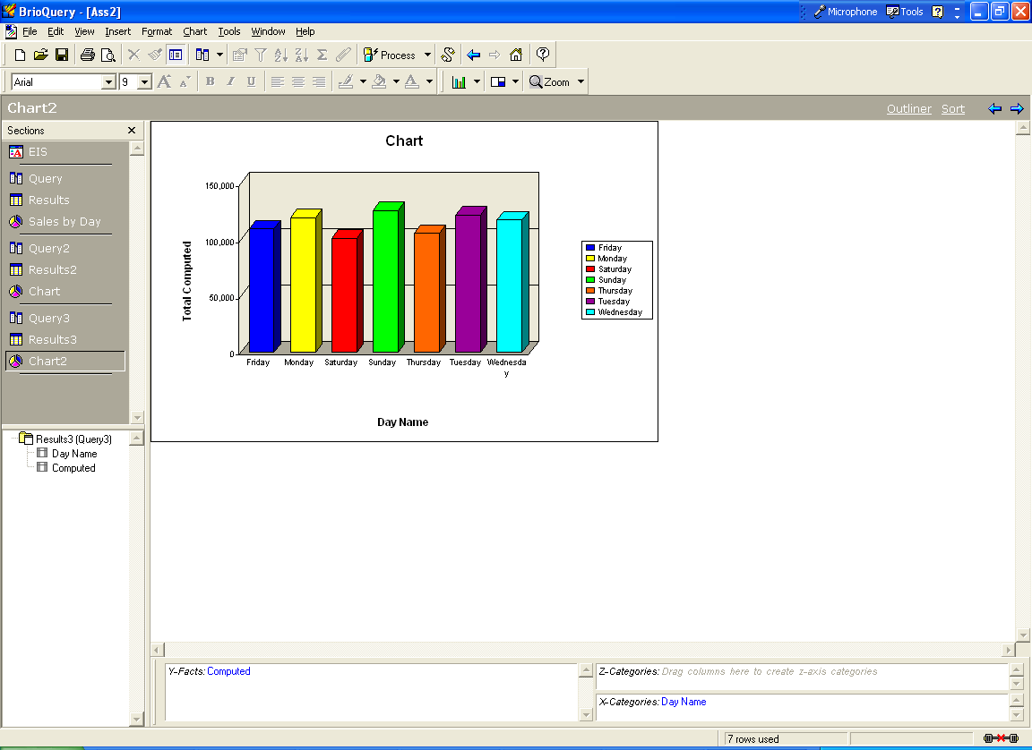

Question 8. Generate a report (using a pivot) that tells a day of the week with the largest number of video units sold by different regions.
Answer 8.
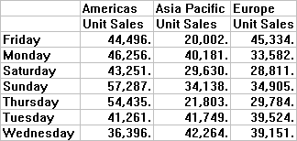

Question 9. Generate a report (using a pivot) that tells a day of the week with the largest number of video units sold by different countries.
Answer9.
 | Argentina | Australia | Brazil | Canada | France | Germany
 | Unit Sales | Unit Sales | Unit Sales | Unit Sales | Unit Sales | Unit Sales
Friday |  | 11,169. | 1,187. | 3,245. | 10,171. | 8,189.
Monday | 314. | 20,429. | 1,386. | 4,657. | 3,883. | 6,355.
Saturday | 1,512. | 22,070. | 117. | 5,577. | 5,100. | 13,751.
Sunday | 1,527. | 18,784. | 1,478. | 16,383. | 5,330. | 4,723.
Thursday | 1,552. | 7,445. | 2,017. | 2,182. | 7,340. | 7,223.
Tuesday | 1,020. | 26,797. | 2,669. | 3,365. | 5,591. | 4,605.
Wednesday | 390. | 20,364. | 1,729. | 2,797. | 9,613. | 8,353.

 | Ireland | Japan | Norway | Sweden | United Kingdom | USA
 | Unit Sales | Unit Sales | Unit Sales | Unit Sales | Unit Sales | Unit Sales
Friday | 2,245. | 8,833. | 390. | 2,015. | 22,324. | 40,064.
Monday | 822. | 19,752. | 83. | 3,626. | 18,813. | 39,899.
Saturday | 950. | 7,560. | 111. | 3,393. | 5,506. | 36,045.
Sunday | 5,541. | 15,354. | 430. | 3,674. | 15,207. | 37,899.
Thursday | 5,556. | 14,358. | 1,667. | 3,991. | 4,007. | 48,684.
Tuesday | 2,719. | 14,952. | 1,677. | 1,639. | 23,293. | 34,207.
Wednesday | 2,901. | 21,900. | 1,088. | 3,761. | 13,435. | 31,480.

Question 10. Take the results generated when answering question 1 and create a chart. Develop an EIS report, which displays the chart and allows for switching between line and bar charts using radio buttons.
Answer 10a. Displays with bar chart (Radio button for bar chart is on)

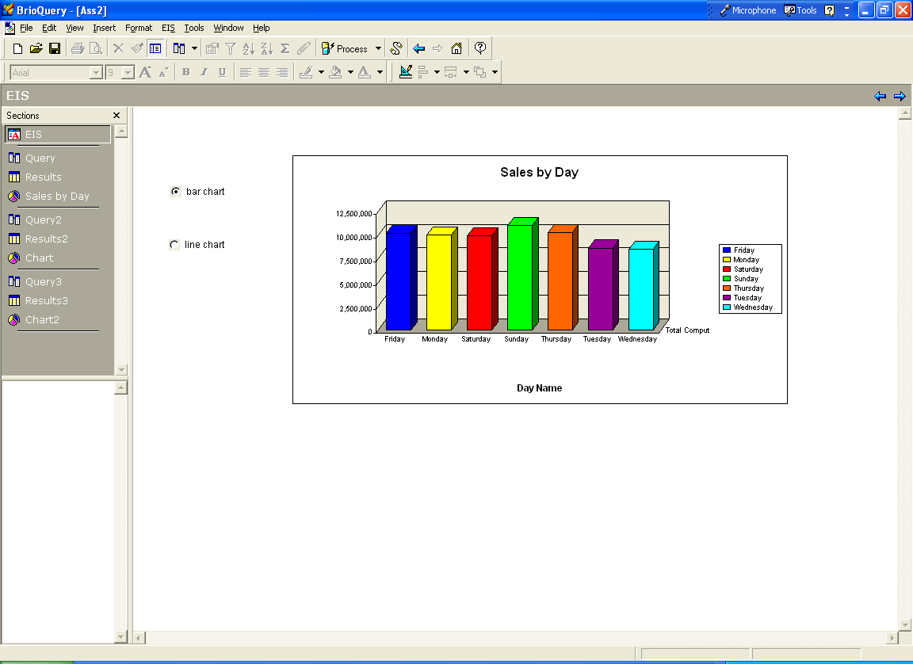

Answer 10b. Displays with line chart (Radio button fro line chart is on)

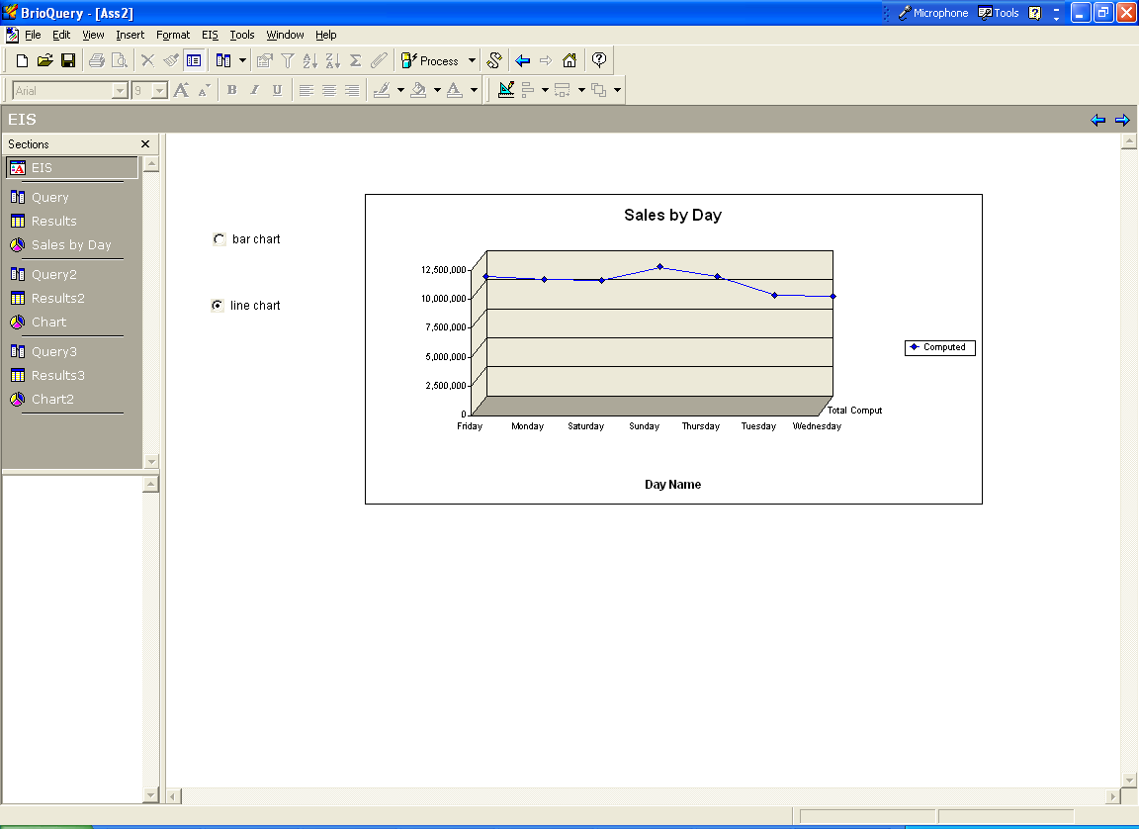

Question 11. Generate an interface for displaying sales amounts for countries and regions. The interface should allow for changing between countries and regions as well as for switching between line and bar charts.

Answer11a. Displays sales amounts for regions with bar chart
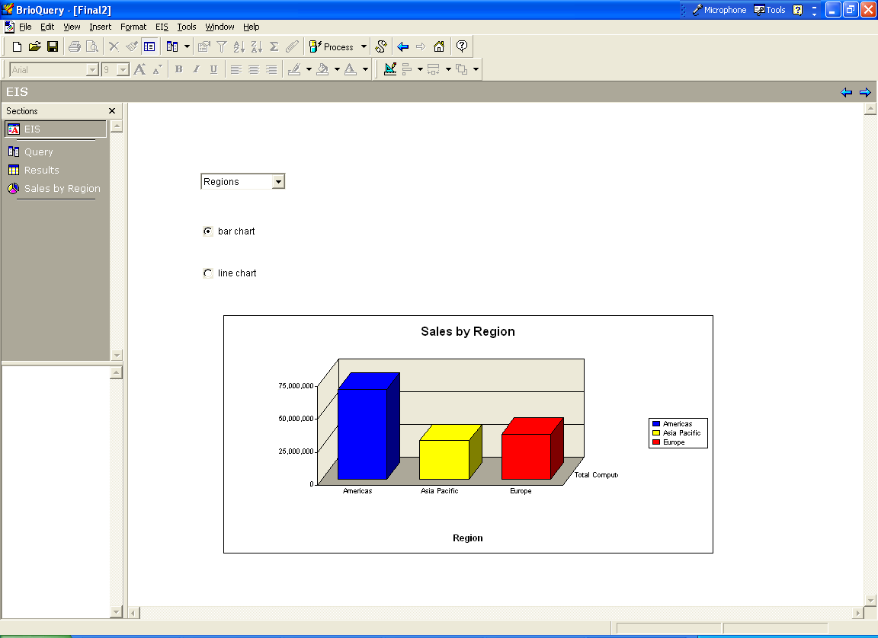
Answer 11b. Displays sales amounts for countries with bar chart. 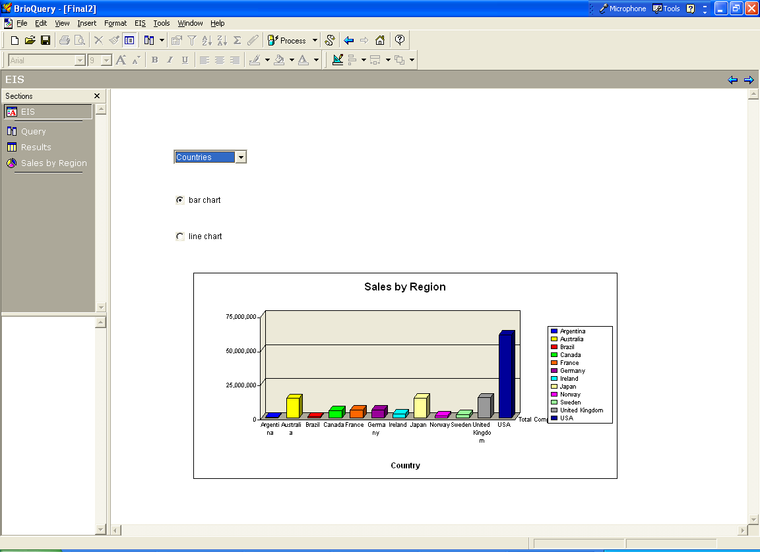

Answer 11c. Displays sales amount for regions with line chart.
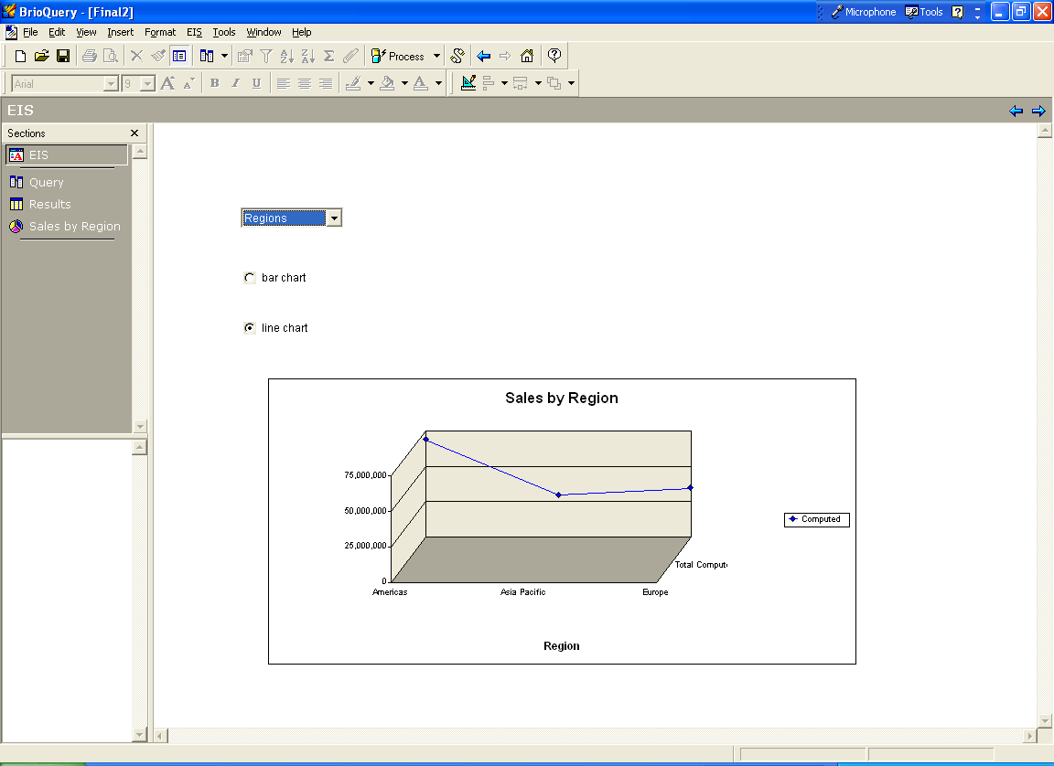
Answer 11d. Displays sales amount for countries with line chart. 